**MACQUARIE UNIVERSITY COLLEGE**

**ASSESSMENT**

**INTRODUCTION TO VIDEO GAMES (WCOM1011)**

**Unity Game Task - Marks Claimed Template**

* **Student ID: 47004029**
* **Student Name: Dylan Neilson**
* **Group: 3**
* **GitHub Username: DylanNeilson**

|  |  |  |  |
| --- | --- | --- | --- |
| Feature | Mark | Claimed?  Yes/No | Location in the game |
| A *First-Person controller* with which the player can navigate the scene | - | **Yes** | **Corridor of space station** |
| Indoor section using ProBuilder and/or Unity primitives (cubes, spheres, etc) | 25% |  |  |
| Outdoor Section using Terrain Editor | 25% | **Yes** | **Outside** |
| Appropriate textures on the indoor section | 5% | **Yes** | **Inside space station** |
| * Texture with normal maps added to indoor section | +5% |  |  |
| A simple single-state animation clip | 5% | **Yes** | **Security Camera monitors inside space station** |
| A complex (multi-state) animation that responds to trigger or mouse events | 5% | **Yes** | **Space station doors** |
| Direct light sources beyond the default Directional Light | 5% | **Yes** |  |
| * Baked indirect lighting in the Indoor section | +5% |  |  |
| * Light-probes for dynamic indirect lighting | +5% |  |  |
| Reflection-probes and reflective surfaces | 5% |  |  |
| Emissive materials | 5% | **Yes** | **Security camera monitors** |
| Appropriately chosen post-processing effects | 5% | **Yes** |  |
| Multiple cameras | 10% | **Yes** | **Four camera objects on each corner of space station** |
| Particle effects | 10% | **Yes** | **In the crater inside space station** |
| Objects controlled by physics | 5% |  |  |
| * Objects controlled by physics with Joints | +5% |  |  |
| Appropriate 3D spatialised audio sources | 5% |  |  |
| Single type, NavMesh Agent | 5% |  |  |
| * Multiple, different types of NavMesh Agents | 5% |  |  |
| Total Claimed | **%75** | | |

**Note:** Totals greater than 100% will be rounded down to 100%.

## Terrain

**Features used**:

* Outdoor Section using Terrain Editor

**Where in Hierarchy**

* Main_Scene/Terrain

**Description**:

Mountainous Mars-Like terrain covered in mushrooms, rocks, large bodies of water and purple trees

**Screenshot**:

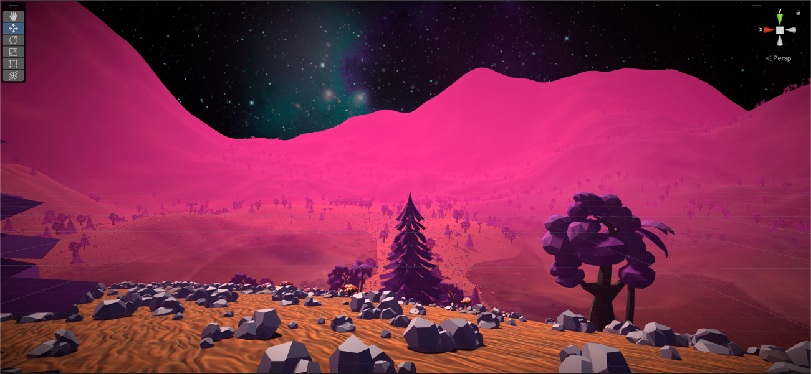

## Indoor Textures

**Features used**:

* Appropriate textures on the indoor section

**Where in Hierarchy**

* Main_Scene/Spacestation

**Description**:

Coloured textures for corridors of space staion

**Screenshot**:

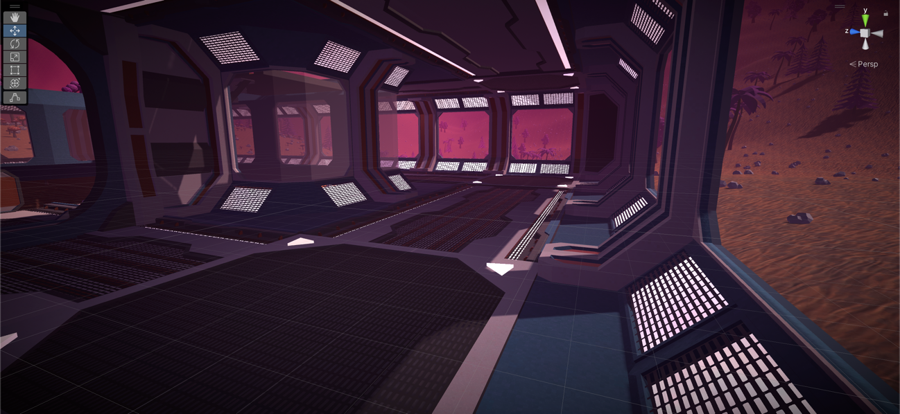

## Swiveling security cameras

**Features used**:

* A simple single-state animation clip

**Where in Hierarchy**

* Assets/Animations

**Description**:

Animations control the movement of four cameras located around the space station

**Screenshot**:

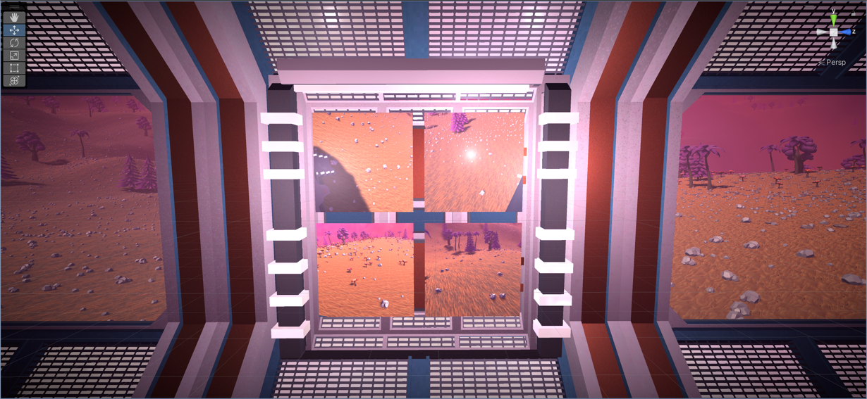

## Space Station Doors

**Features used**:

* A complex (multi-state) animation that responds to trigger or mouse events

**Where in Hierarchy**

* Assets/Models/Sci-Fi Styled Modular Pack/Animations

**Description**:

Animations control the doors within the space station which are controlled by a trigger box that interacts with the player object.

**Screenshot**:

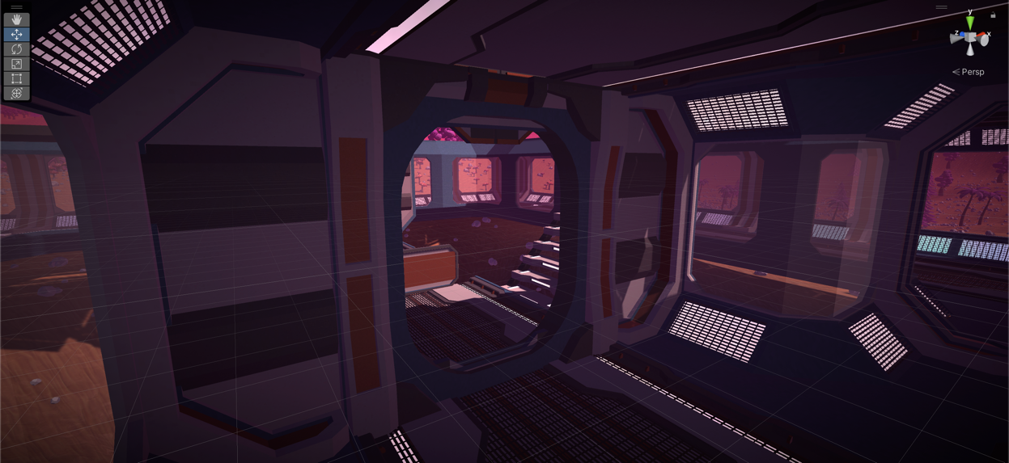

## Spacestaton Ceiling Lights

**Features used**:

* Direct [light sources](https://docs.unity3d.com/Manual/LightSources.html) beyond the default Directional Light

**Where in Hierarchy**

* Main_Scene/Spacestation/Lighting/light_wall_1

**Description**:

Multiple ceiling lights within the corridors of the space station

**Screenshot**:

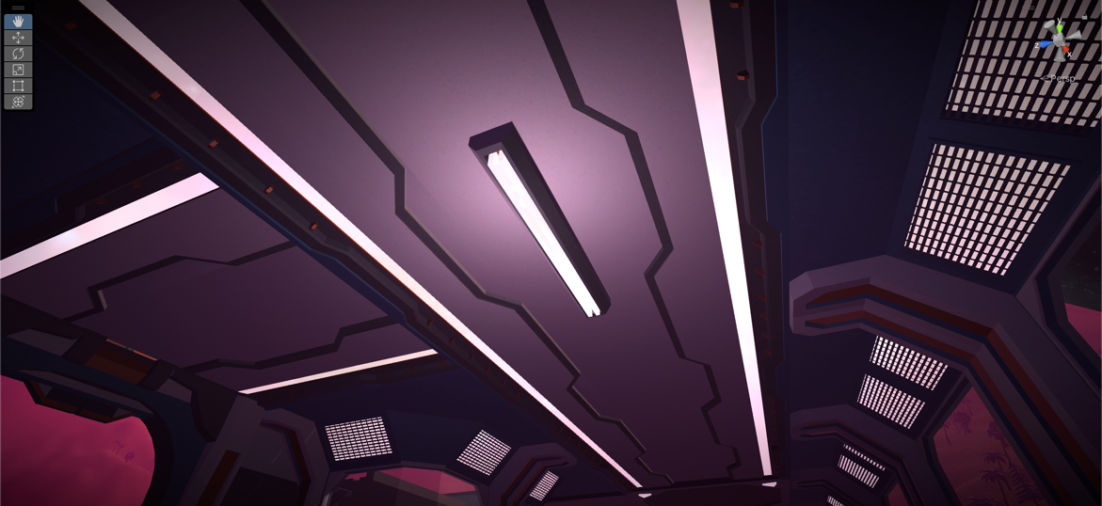

## Security Camera Monitors

**Features used**:

* Emissive materials

**Where in Hierarchy**

* Assets/Materials

**Description**:

The Security camera monitors in the Space station use emissive materials to display the output of the camera object

**Screenshot**:

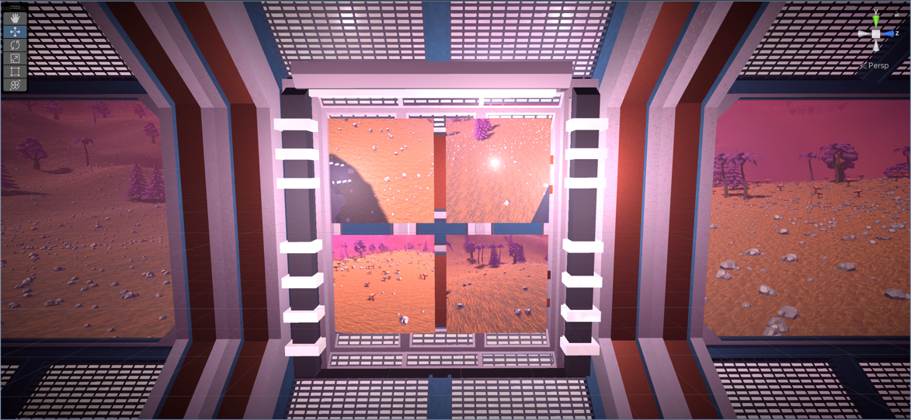

## Atmospheric Post Processing

**Features used**:

* Appropriately chosen post-processing effects.

**Where in Hierarchy**

* Main_Scene/GlobalPostProcessing

**Description**:

Added orange hue and vignette

**Screenshot**:

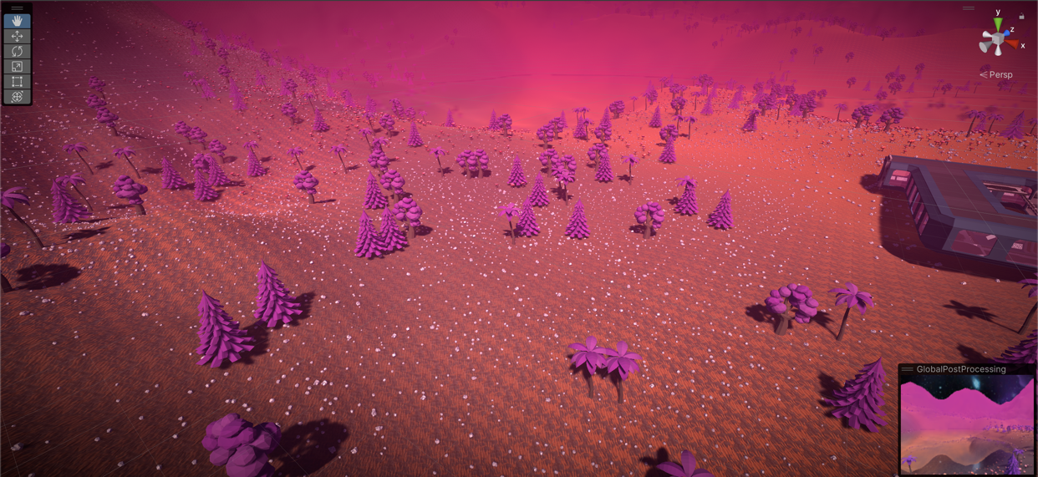

## Security Cameras

**Features used**:

* Multiple Cameras

**Where in Hierarchy**

* Main_Scene/Cameras

**Description**:

Four security cameras on each corner of space station

**Screenshot**:

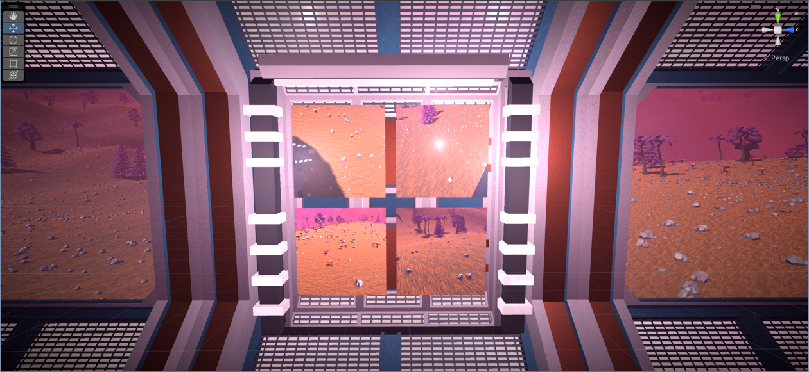

## Particles emitting from crater

**Features used**:

* Particle Effects

**Where in Hierarchy**

* Main_Scene/Spacestation/Orange Mist

**Description**:

Orange particles emitting from space station built around crater.

**Screenshot**:

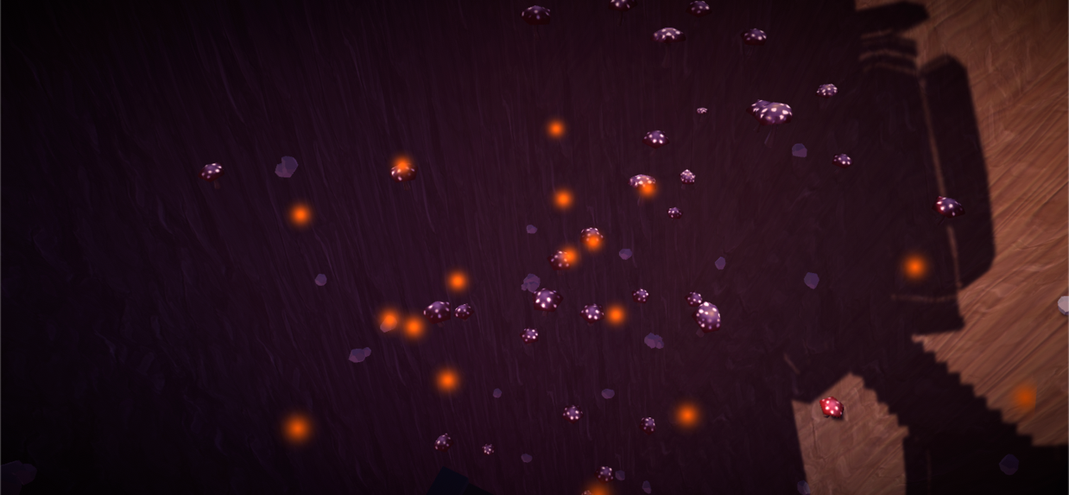

# Assets Used

|  |  |  |  |
| --- | --- | --- | --- |
| Assets used | Location | Name | Link |
| Rocks | Assets/Models/BrokenVector/LowPolyRockPack | Low Poly Rock Pack | https://assetstore.unity.com/packages/3d/environments/low-poly-rock-pack-57874#reviews |
| Trees | Assets/Models/Darth_Artisan/Free_Trees | Free Trees | https://assetstore.unity.com/packages/3d/vegetation/trees/free-trees-103208#reviews |
| Mushroom Models | Assets/Models/Toby Fredson/Hand Painted Tiles – SleepingForest | Painted Tiles – Sleeping Forest | https://assetstore.unity.com/packages/2d/textures-materials/painted-tiles-sleeping-forest-49170#reviews |
| Spacestation Components | Assets/Models/Sci-Fi Styled Modular Pack | Sci-Fi Styled Modular Pack | https://assetstore.unity.com/packages/3d/environments/sci-fi/sci-fi-styled-modular-pack-82913#reviews |
| Grass | Assets/Materials/LowlyPoly/Stylized Grass Texture | Stylized Grass Texture | https://assetstore.unity.com/packages/2d/textures-materials/glass/stylized-grass-texture-153153#reviews |
| Sand, Stone | Assets/Materials/Blink/Art/Textures | FREE Stylized Textures - RPG Environment | https://assetstore.unity.com/packages/2d/textures-materials/free-stylized-textures-rpg-environment-204187#reviews |
| Skybox | Assets/Materials/Skybox/DeepSpaceSkyboxPack | Deep Space Skybox Pack | https://assetstore.unity.com/packages/2d/textures-materials/deep-space-skybox-pack-11056#reviews |